BANK LOAN REPORT QUERY DOCUMENT

- Bank Loan Report || summary
KPI’s:
- Total Loan Applications
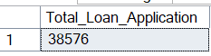

- MTD Loan Application
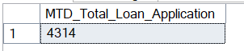

- PMTD Loan Application
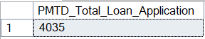

- Total Funded amount
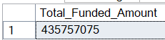

- MTD Total funded amount
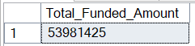

- PMTD Total Funded amount
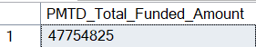

- Total amount received
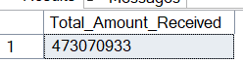

- MTD Total amount Received
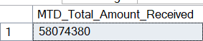
- PMTD Total amount Received
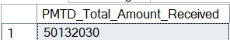

- Avg interest rate
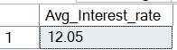

- AVG MTD Interest Rate.
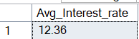

- AVG PMTD Interest Rate.
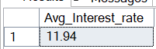

- AVG dti
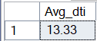

- MTD DTI
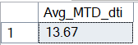

avg pmtd dti
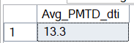
GOOD LOAN ISSUED
- Percentage of Good Loan
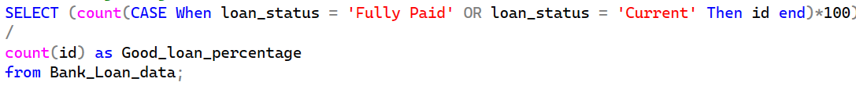
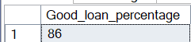

- Good Loan applications
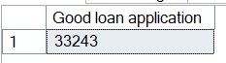

- Good loan funded amount
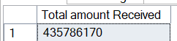

- Good Loan Amount Received
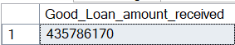
Bad LOAN ISSUED

- Bad Loan Percentage
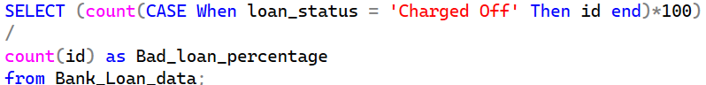
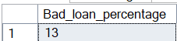

- Bad loan application
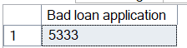

- Bad loan funded amount
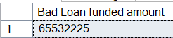

Bad Loan Amount Received
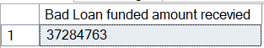
LOAN STATUS

- Loan status
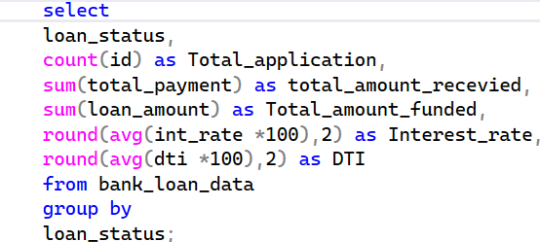
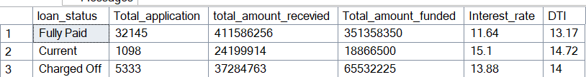

- MTD Loan Status
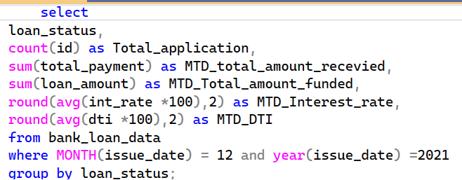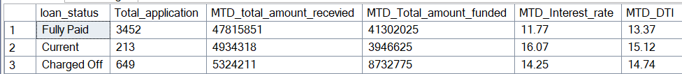
23) PMTD Loan Status
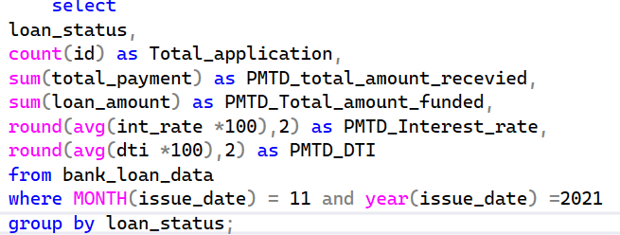
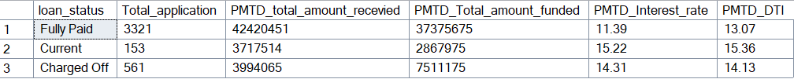

BANK LOAN REPORT | OVERVIEW
MONTH
Monthly Trends by issue date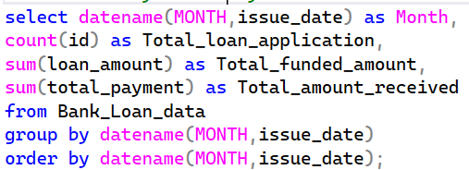
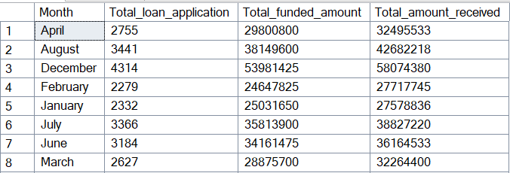

Regional Analysis by state
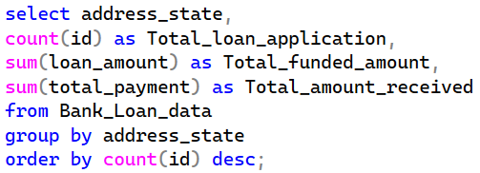
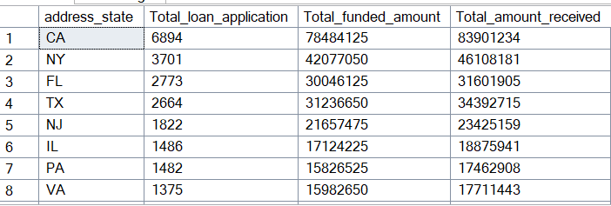
loan Term analysis
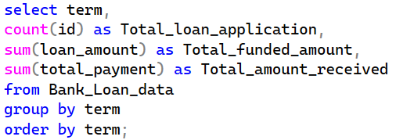
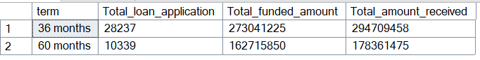
employee length analysis
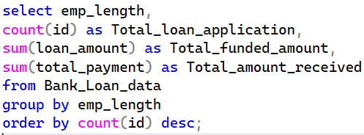
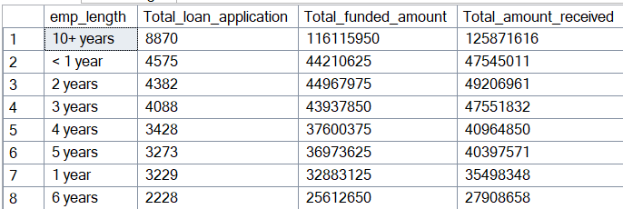
what purpose
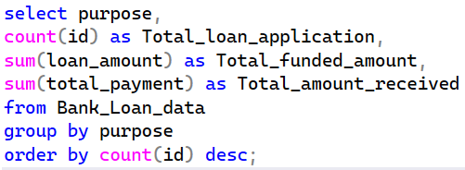
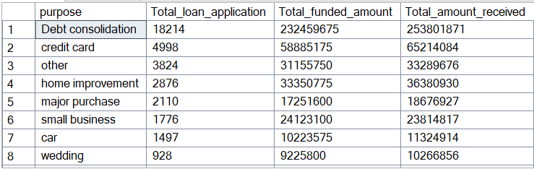
home ownership
